PaintZilla

Submitted in partial fulfillment of the requirements

of the mini project of

Internet Programming

by

Abhijit Turate

Priyanka Shinde

Kesha Mehta

Supervisor:

Prof. Pankaj Kunekar



Department of Information Technology

Atharva College of Engineering

Year: 2020-21



**ATHARVA COLLEGE OF ENGINEERING**

**MALAD (W), MUMBAI 400 095**

**YEAR: 2020-2021**

CERTIFICATE

*This is to certify that*

**Abhijit Turate**

**Priyanka Shinde**

**Kesha Mehta**

*have submitted the mini project report for the requirements of*

*Internet Programming satisfactorily*

on

**“PaintZilla”**

*As prescribed by the* ***University of Mumbai*** *Under the guidance of*

**PROJECT GUIDE** **H.O.D.** **PRINCIPAL**

**INTERNAL EXAMINER** **COLLEGE SEAL** **EXTERNAL EXAMINER**

Approval for Mini Project Report

This project report entitled **‘Painting website’** by **Abhijit Turate, Priyanka Shinde and Kesha Mehta** is approved for the degree of ***Bachelor of Engineering in Information Technology.***

Internal Examiners. -----------------------------

Project Guide. -----------------------------------

Date:

Place:

Declaration

I declare that this written submission represents my ideas in my own words and where others' ideas or words have been included, I have adequately cited and referenced the original sources. I also declare that I have adhered to all principles of academic honesty and integrity and have not misrepresented or fabricated or falsified any idea/data/fact/source in my submission. I understand that any violation of the above will be cause for disciplinary action by the Institute and can also evoke penal action from the sources which have thus not been properly cited or from whom proper permission has not been taken when needed.

-----------------------------------------

Abhijit Turate(70)

-----------------------------------------

Priyanka Shinde(71)

-----------------------------------------

Kesha Mehta (74)

Date:

**ABSTRACT**

Painters and artists can express themselves through beautiful visuals and bold strokes of colour and texture. Painting is poetry that is seen rather than felt, and poetry is painting that is felt rather than seen. Painting, the expression of ideas and emotions with the creation of certain aesthetic qualities, in two-dimensional visual language. In our country, artists and their art doesn’t get much recognition. A lot of local artists don’t get platform to showcase their talent. PaintZilla will help promote their art and provide an easy platform to showcase talent and earn from it.

**INDEX**

|  |  |  |
| --- | --- | --- |
| **Chapter**  **No.** | **Topic** | **Page No.** |
| Chapter 1 | Introduction | 7 |
| Chapter 2 | Literature Review | 10 |
| Chapter 3 | Requirement Analysis | 13 |
| Chapter 4 | System Design | 16 |
| Chapter 5 | Details of Software | 23 |
| Chapter 6 | Implementation | 25 |
| Chapter 7 | Testing Procedure | 34 |
| Chapter 8 | Gantt Chart | 38 |
| Chapter 9 | Conclusion | 42 |
| Chapter 10 | Future Scope | 44 |
|  | References | 46 |

**LIST OF TABLES AND FIGURES**

|  |  |  |
| --- | --- | --- |
| **Fig/Table No.** | **Name of figure** | **Page No.** |
| Table no. 2.1 | Summary of Literature Review | 12 |
| Fig 4.1 | UML diagram | 18 |
| Fig 4.2 | Level 0 DFD diagram | 19 |
| Fig 4.3 | Level 1 DFD diagram | 19 |
| Fig 4.4 | Level 2 DFD diagram | 20 |
| Fig 4.5 | ER Diagram | 22 |
| Table no. 5.1 | Software used | 24 |
| Table no. 7.1 | Test cases for login and registration | 36 |
| Table no. 7.2 | Test cases for cart | 37 |
| Table no. 8.1 | Project Development Phases | 39 |
| Table no. 8.2 | Work Task 1: Analysis Phase | 40 |
| Table no. 8.3 | Work task 2: Design Phase | 40 |
| Table no. 8.4 | Work task 3: coding, deployment and documentation phase | 41 |

**CHAPTER 1**

**INTRODUCTION OF TITLE**

**1. INTRODUCTION**

Art is generally understood as any activity or product done by people with a communicative or aesthetic purpose—something that expresses an idea, an emotion or, more generally, a **world view.**It is a component of culture, reflecting economic and social substrates in its design. It transmits ideas and values inherent in every culture across space and time. Its role changes through time, acquiring more of an aesthetic component here and a socio-educational function there.Art historians and philosophers of art have long had classificatory disputes about art regarding whether a particular cultural form or piece of work should be classified as art.While the definition of art has changed over the years, the field of art history has developed to allow us to categorize changes in art over time and to better understand how art shapes and is shaped by the creative impulses of artists. Though art has evolved worldwide but still somewhere it doesn’t get the desired recognition in our country. There isn’t enough platforms for the beginners or for local artists to showcase their talent. PaintZilla provides such artists a platform to showcase their talent and earn from it. Artists will also get the deserved recognition. All types of paintings will be available on our website.

1.1 NEED

The need for the application defines not only the usefulness of the application but the expectations of the development team involved. The application is user friendly It is an application for general people. It has an application in music therapy.

1.2 PROBLEM STATEMENT

When an artist makes the decision to sell their artwork they make decision to start a business and most businesses need a website and audience. This website is a great place for artists to sell their artwork as it will have the required audience. Artists will be able to sell their work without the need of a middleman. Having an online platform will enhance the perception of professionalism regarding artists art. It allows artist to positively build up their reputation by giving people the opportunity to learn about who they are as an artist.

1.3 AIM AND OBJECTIVE

PaintZilla is a novel approach that helps the artist to increase their reach and allow them to sell their artwork hustle free. The primary objective is to promote art in our country, to encourage beginners and local artists and provide them with a ready platform with enough audience to showcase their talent and let artists gain the desired recognition and allow them to earn by selling their work without any middleman getting involved.

1.4 APPLICATIONS

The proposed system is useful for all type of artists let they be beginners, experienced or local artists. All types of paintings will be available like acrylic, abstract, oil, watercolour, etc. This will help artists to promote their artwork without investing in anything. No middleman will be involved so that the buyers and artists could communicate directly easily.

1.5 SCOPE

PaintZilla must include a forum which will help the buyers to directly communicate with the artists. A customization section can also be included in which the buyers will be able to request artists for their customised paintings. The scope of the application defines not only the usefulness of the application but the expectations of the development team involved. It is a luxury application for artists. It has a major future scope

**CHAPTER 2**

**REVIEW OF LITERATURE**

**REVIEW OF LITERATURE**

2.1 LITERATURE REVIEW

Online Paint Sales- Industry Market Research Report, IBISWorld, July 2019.

The Online Paint Sales industry has grown steadily over the five years to 2019, as both construction activity and rising e-commerce sales boosted demand for industry products. Paint sales rely heavily on the overall housing market; therefore, as housing starts and private spending on home improvement grew strongly, demand for online paint grew significantly as well. Furthermore, consumers have increasingly turned to online shopping due to the convenience and ability to browse the widest selection of products while at the same time finding the best price. As a result, e-commerce has expanded over the five years to 2019, boosting industry revenue. Overall, industry revenue has increased during the current period. Over the five years to 2024, industry revenue is forecast to continue to rise. An increasing number of traditional brick-and-mortar paint stores are anticipated to establish online platforms, contributing to the growing number of industry enterprises. This industry sells household paint over the internet to consumers and construction contractors. Sales include exterior paint, interior paint, stains and varnishes.  
This report covers the scope, size, disposition and growth of the industry including the key sensitivities and success factors. Also included are five year industry forecasts, growth rates and an analysis of the industry key players and their market shares.

Art of Artists, Online Art Gallery, Dr. Kamal, November 2019.

This is a web application. The objective of the project is to showcase all the arts made by different artists around the world. Our main aim is to provide a platform, where one can view all the different types of arts created by different artists. This project will help others to gain information about the various trending arts and place order according to their need. One can also view the prices of the various items. Our purpose of selecting this topic is that artist creates different types of art but they don’t find a proper platform to show their creativity to the world. Art of artists helps the user to view images available on website, from here user can select their images and they can contact us if they want by the images. All information related to every image is also available on the website. Project is created with the front end as PHP and back end as MY SQL.

2.2 EXISTING SITES

Currently, there are some sites. Some of the interesting applications among them are:

* www.artzolo.com
* www.fizdi.com
* www.gallerist.com
* www.mojarto.com

2.4 SUMMARY OF LITERATURE REVIEW

Table 2.1: Summary of Literature Review

|  |  |  |  |  |  |  |  |  |  |  |
| --- | --- | --- | --- | --- | --- | --- | --- | --- | --- | --- |
| Sr. No. | Paper Name | Author/s | Year | Summary | | |  |  |  |  |
|  |  |  |  |  | | | | | | |
| 1 | Art of Artists | Dr. Kamal | 2019 | It’s objective is to showcase all the arts made by different artists around the world | | | | | | |
|  |  |  |  |  |  | | | | |  |
|  |  |  |  |  | | | |  |  |  |
|  |  |  |  |  |  |  |  |  |  |  |
|  |  |  |  |  |  |  |  |  |  |  |
|  |  |  |  |  | | | | | | |
| 2 | Online Paint Sales- Industry Market Research Report | IBISWorld | 2019 | The Online Paint Sales industry has grown steadily over the five years to 2019, as both construction activity and rising e-commerce sales boosted demand for industry products. Paint sales rely heavily on the overall housing market; therefore, as housing starts and private spending on home improvement grew strongly, demand for online paint grew significantly as well. Furthermore, consumers have increasingly turned to online shopping due to the convenience and ability to browse the widest selection of products while at the same time finding the best price | | | | | | |
|  |  |  |  |  | | |  | | |  |
|  |  |  |  |  | | | | | | |
|  |  |  |  |  | |  | |  |  | |
|  |  |  |  |  | | | | | | |
|  |  |  |  |  | | | | | | |
|  |  |  |  |  | | |  |  |  |  |
|  |  |  |  |  | | |  |  |  |  |
|  |  |  |  |  | | |  |  |  |  |
|  |  |  |  |  |  |  | | |  | |
|  |  |  |  |  |  |  | | |  | |
|  |  |  |  |  |  |  | | |  | |

**CHAPTER 3**

**REQUIREMENT ANALYSIS**

**REQUIREMENT ANALYSIS**

Requirements analysis in systems engineering and software engineering, encompasses those tasks that go into determining the needs or conditions to meet for a new or altered product, taking account of the possibly conflicting requirements of the various stakeholders, such as beneficiaries or users. A software requirements specification (SRS) is a document that is created when a detailed description of all aspects of the software to be built must be specified before the project is to commence. It is important to note that a formal SRS is not always written. In fact, there are many instances in which effort expended on a SRS might be better spent in other software engineering activities.Requirements analysis is critical to the success of a development project. Requirements must be actionable, measurable, testable, related to identified business needs or opportunities, and defined to a level of detail sufficient for system design. By analyzing different hardware components and familiar software following are hardware & software used in our project:

### 3.1 HTML

HTML (**H**yper**t**ext **M**arkup **L**anguage) is the code that is used to structure a web page and its content. For example, content could be structured within a set of paragraphs, a list of bulleted points, or using images and data tables. As the title suggests, this article will give you a basic understanding of HTML and its functions. HTML is not a programming language; it is a markup language that defines the structure of your content. HTML consists of a series of [elements](https://developer.mozilla.org/en-US/docs/Glossary/element), which you use to enclose, or wrap, different parts of the content to make it appear a certain way, or act a certain way. The enclosing [tags](https://developer.mozilla.org/en-US/docs/Glossary/tag) can make a word or image hyperlink to somewhere else, can italicize words, can make the font bigger or smaller, and so on.

3.2 JAVASCRIPT

JavaScript is a high-level, interpreted scripting language that conforms to the ECMA Script specification. JavaScript has curly-bracket syntax, dynamic typing, prototype- based object-orientation, and first-class functions. Alongside HTML and CSS, JavaScript is one of the core technologies of the World Wide Web. JavaScript enables interactive web pages and is an essential part of web applications. The vast majority of websites use it and major web browsers have a dedicated JavaScript engine to execute it. As a multi-paradigm language, JavaScript supports event-driven, functional, and imperative (including object-oriented and prototype-based) programming styles. It has APIs for working with text, arrays, dates, regular expressions, and the DOM, but the language itself does not include any I/O, such as networking, storage, or graphics facilities. It relies upon the host environment in which it is embedded to provide these features. Initially only implemented client-side in web browsers, JavaScript engines are now embedded in many other types of host software, including server-side in web servers and databases, and in non-web programs such as word processors and PDF software, and in runtime environments that make JavaScript available for writing mobile and desktop applications, including desktop widgets.

### 3.3 XAMMP SERVER

XAMPP is a free and open-source cross-platform web server solution stack package developed by Apache Friends, consisting mainly of the Apache HTTP Server, MariaDB database, and interpreters for scripts written in the PHP and Perl programming languages. Since most actual web server deployments use the same components as XAMPP, it makes transitioning from a local test server to a live server possible. XAMPP's ease of deployment means a WAMP or LAMP stack can be installed quickly and simply on an operating system by a developer. With the advantage a number of common add-in applications such as WordPress and Joomla! can also be installed with similar ease using Bitnami.

3.4 MYSQL

MySQL is an open-source relational database management system (RDBMS). MySQL is free and open-source software under the terms of the GNU General Public License, and is also available under a variety of proprietary licenses. MySQL was owned and sponsored by the Swedish company MySQL AB, which was bought and can be use by Sun Microsystems (now Oracle Corporation) In 2010, when Oracle acquired Sun, Widenius forked the open-source MySQL project to create MariaDB.

## 3.5 Php

PHP is a general-purpose scripting language especially suited to web development. It was originally created by Danish-Canadian programmer RasmusLerdorf in 1994. The PHP reference implementation is now produced by The PHP Group. PHP originally stood for Personal Home Page, but it now stands for the recursive initialism PHP: Hypertext Preprocessor phpcode is usually processed on a web server by PHP interpreter implemented as a module, a daemon or as a Common Gateway Interface (CGI) executable. On a web server, the result of the interpreted and executed PHP code – which may be any type of data, such as generated HTML or binary image data – would form the whole or part of HTTP response.

**CHAPTER 4**

**SYSTEM DESIGN**

**SYSTEM DESIGN**

4.1 UML DIAGRAM:

In the Unified Modelling Language (UML), a use case diagram can summarize the details of your system's users (also known as actors) and their interactions with the system. To build one, you'll use a set of specialized symbols and connectors. An effective use case diagram can help your team discuss and represent:

1. Scenarios in which your system or application interacts with people, organizations, or external systems
2. Goals that your system or application helps those entities (known as actors) achieve
3. The scope of your system

Use case diagram components:

1. **Actors**: The users that interact with a system. An actor can be a person, an organization, or an outside system that interacts with your application or system. They must be external objects that produce or consume data.
2. **System**: A specific sequence of actions and interactions between actors and the system. A system may also be referred to as a scenario.
3. **Goals**: The end result of most use cases. A successful diagram should describe the activities and variants used to reach the goal.

Use case diagram symbols and notation:

The notation for a use case diagram is pretty straightforward and doesn't involve as many types of symbols as other UML diagrams.

1. **Use cases:** Horizontally shaped ovals that represent the different uses that a user might have.
2. **Actors:** Stick figures that represent the people actually employing the use cases.
3. **Associations:** A line between actors and use cases. In complex diagrams, it is important to know which actors are associated with which use cases.
4. **System boundary boxes:** A box that sets a system scope to use cases. All use cases outside the box would be considered outside the scope of that system. For example, Psycho Killer is outside the scope of occupations in the chainsaw example found below.
5. **Packages:** A UML shape that allows you to put different elements into groups. Just as with component diagrams, these groupings are represented as file folders.

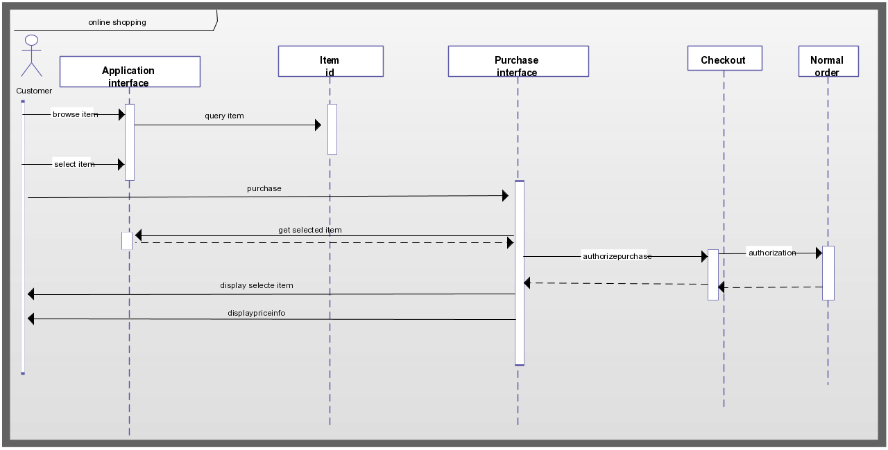

Fig. 4.1 UML diagram

4.2 DFD DIAGRAM:

Data flow diagrams are used to graphically represent the flow of data in a business information system. DFD describes the processes that are involved in a system to transfer data from the input to the file storage and reports generation. Data flow diagrams can be divided into logical and physical. The logical data flow diagram describes flow of data through a system to perform certain functionality of a business. The physical data flow diagram describes the implementation of the logical data flow. DFD graphically representing the functions, or processes, which capture, manipulate, store, and distribute data between a system and its environment and between components of a system. The visual representation makes it a good communication tool between User and System designer. Structure of DFD allows starting from a broad overview and expands it to a hierarchy of detailed diagrams.

#### Level 0

#### https://meeraacademy.com/wp-content/uploads/2016/09/olevel.jpgFIG 4.2 Level 0

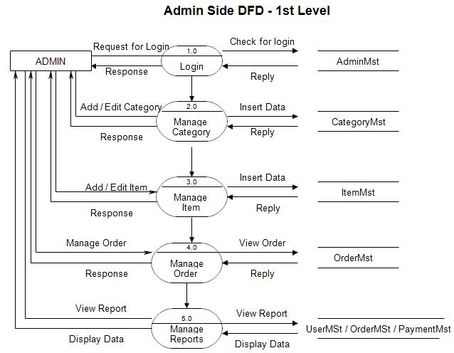**Level 1-**

Admin side User side

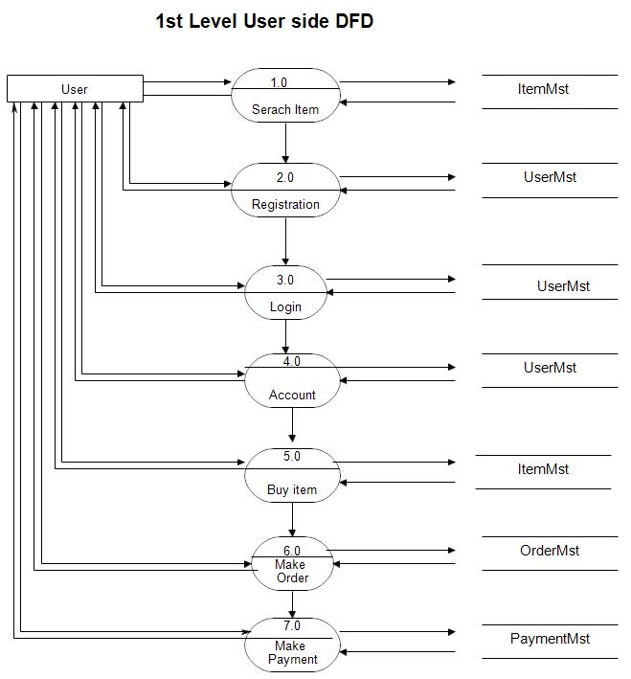

FIG 4.3 :Level 1

**Level 2-**

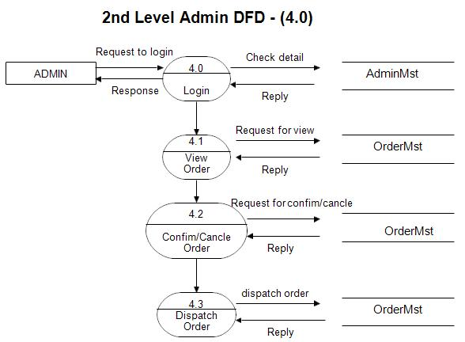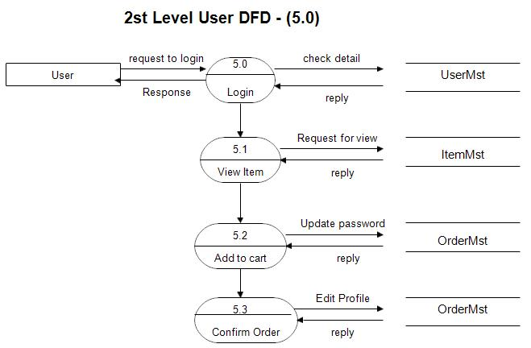Admin side User side

FIG 4.4 :Level 2

4.3 SEQUENCE DIAGRAM:

A sequence diagram shows object interactions arranged in time sequence. It depicts the objects and classes involved in the scenario and the sequence of messages exchanged between the objects needed to carry out the functionality of the scenario. Sequence diagrams are typically associated with use case realizations in the Logical View of the system under development. Sequence diagrams are sometimes called event diagrams or event scenarios. A sequence diagram shows, as parallel vertical lines, different processes or objects that live simultaneously, and, as horizontal arrows, the messages exchanged between them, in the order in which they occur. This allows the specification of simple runtime scenarios in a graphical manner. It represents the behavioural aspects of a system. Sequence diagram shows the interactions between the objects by means of passing messages from one object to another with respect to time in a system.

Elements in sequence diagram.

* **Object:** Objects appear at the top portion of sequence diagram. Object is shown in a rectangle box. Name of object precedes a colon and the class name, from which the object is instantiated. The whole string is underlined and appears in a rectangle box. Also, we may use only class name or only instance name.
* **Life-line bar:** A down-ward vertical line from object-box is shown as the life-line of the object. A rectangle bar on life-line indicates that it is active at that point of time.
* **Messages:** Messages are shown as an arrow from the life-line of sender object to the life-line of receiver object and labeled with the message name. Chronological order of the messages passing throughout the objects’ life-line show the sequence in which they occur . There may exist some different types of messages.
* **Synchronous messages:** Receiver start processing the message after receiving it and sender needs to wait until it is made. A straight arrow with close and fill arrow-head from sender life-line bar to receiver end, represent a synchronous message.

**9.4 ER DIAGRAM:**

An entity relationship diagram (ERD), also known as an entity relationship model, is a graphical representation that depicts relationships among people, objects, places, concepts or events within an information technology (IT) system. An ERD uses data modelling techniques that can help define business processes and serve as the foundation for a relational database.

Importance of ERDs and their uses

Entity relationship diagrams provide a visual starting point for database design that can also be used to help determine information system requirements throughout an organization. After a relational database is rolled out, an ERD can still serve as a reference point, should any debugging or business process re-engineering be needed later.

However, while an ERD can be useful for organizing data that can be represented by a relational structure, it can't sufficiently represent semi-structured or unstructured data. It's also unlikely to be helpful on its own in integrating data into a pre-existing information system.

There are five basic components of an entity relationship diagram. Similar components will be designated by the same shape. For example, all entities types might be enclosed in a rectangle, while all attributes are enclosed in a diamond.

The components include:

1. Entities, which are objects or concepts that can have data stored about them. Entities refer to tables used in databases.
2. Attributes, which are properties or characteristics of entities. An ERD attribute can be denoted as a primary key, which identifies a unique attribute, or a foreign key, which can be assigned to multiple attributes.
3. The relationships between and among those entities.
4. Actions, which describe how entities share information in the database.
5. Connecting lines

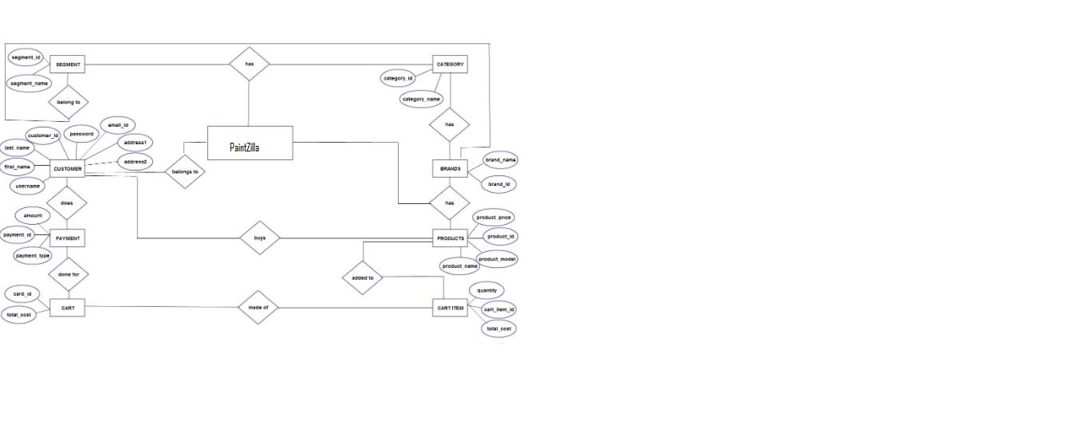

*Fig 4.5:* ER Diagram

**CHAPTER 5**

**DETAILS OF SOFTWARE**

**DETAILS OF SOFTWARE**

5.1 SOFTWARE USED

The software used for the development of the project is:

Table 5.1: Software used

|  |  |
| --- | --- |
| 1. Operating System | Windows 10 (64 bit) |
| 2. Coding Language | PHP |
| 3. Software | XAMP, Sublime text editor |

**CHAPTER 6**

**IMPLEMENTATION**

6.1 Implementation

After the design was made and the problems arising from the design process where clarified and dealt with, it was time to start implementing the application. The implementation was carried out using basic languages of web development for the frontend as well as backend. The frontend and backend were carried out simultaneously for faster development.

* The Website Design

The website design was agreed upon by roughly designing the layout it in a graphic designing software. All the implementation of the design for actually building the website was done using Brackets Text Editor or Visual Studio Code Text Editor.

* The Master Page or Index Page

The master page consists of a navigation bar containing the links to the signup page and login page. The page contains a login and sign up form for users. A new user can sign up first and then login to the home page whereas existing users can login to the home page directly.

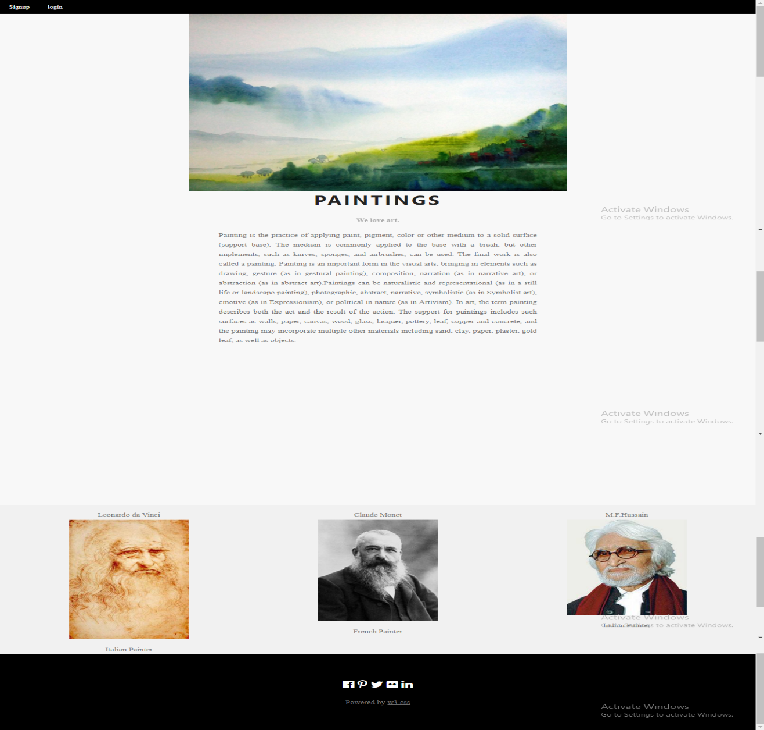

* Sign up

Next, page consists of steps of how a new user can use the website for his own benefit. User can go through many painting in catalog or user can go to respective types of painting.

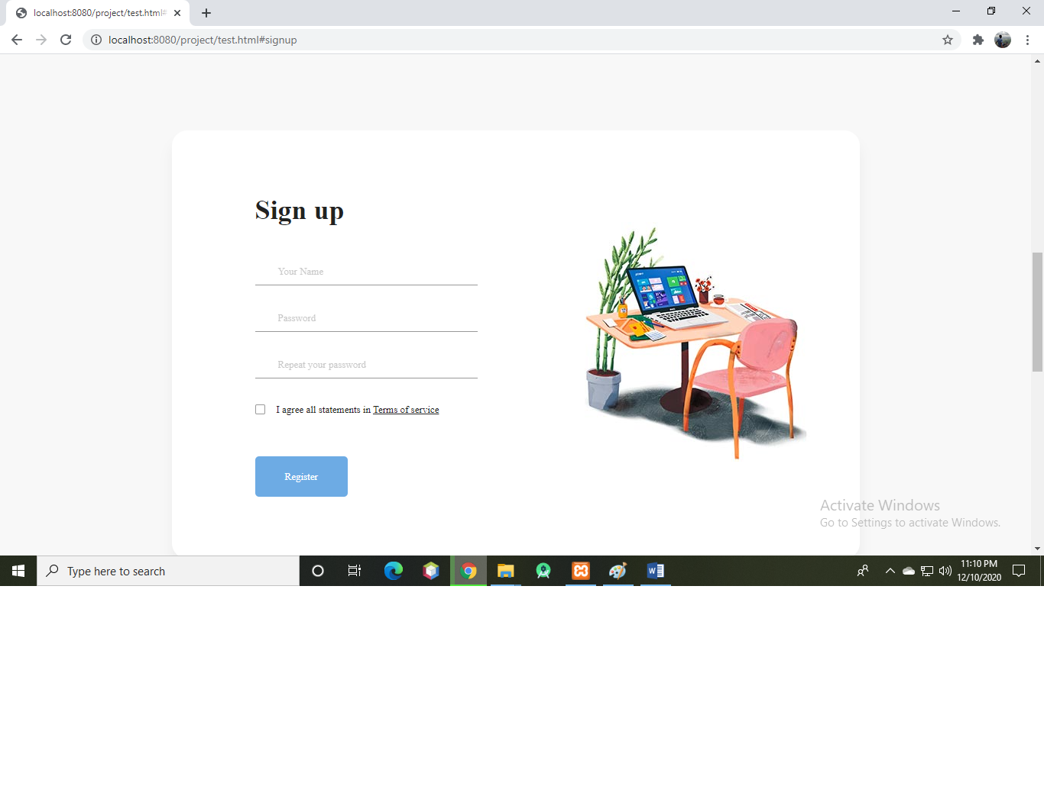

* Navigation bar:

Navigation bar helps the user to jump to others pages of the website. Also, the nav bar is used to logout from your account.

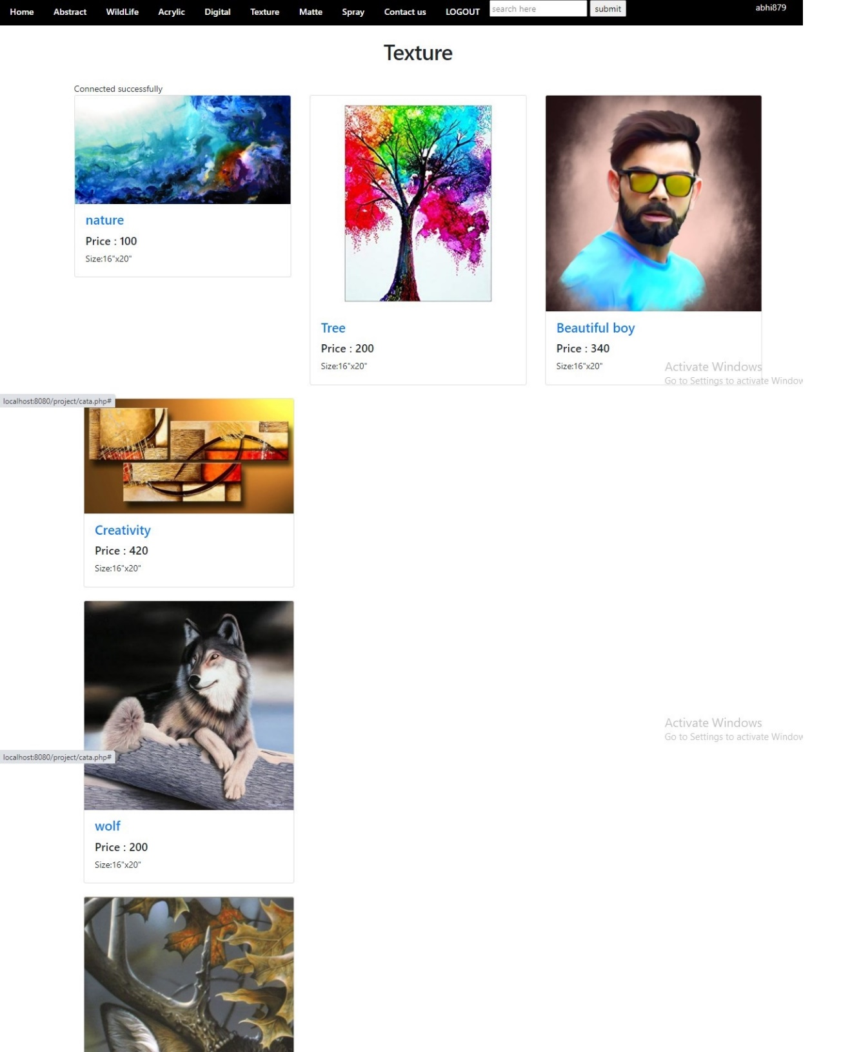

* Categories-

1. Abstract

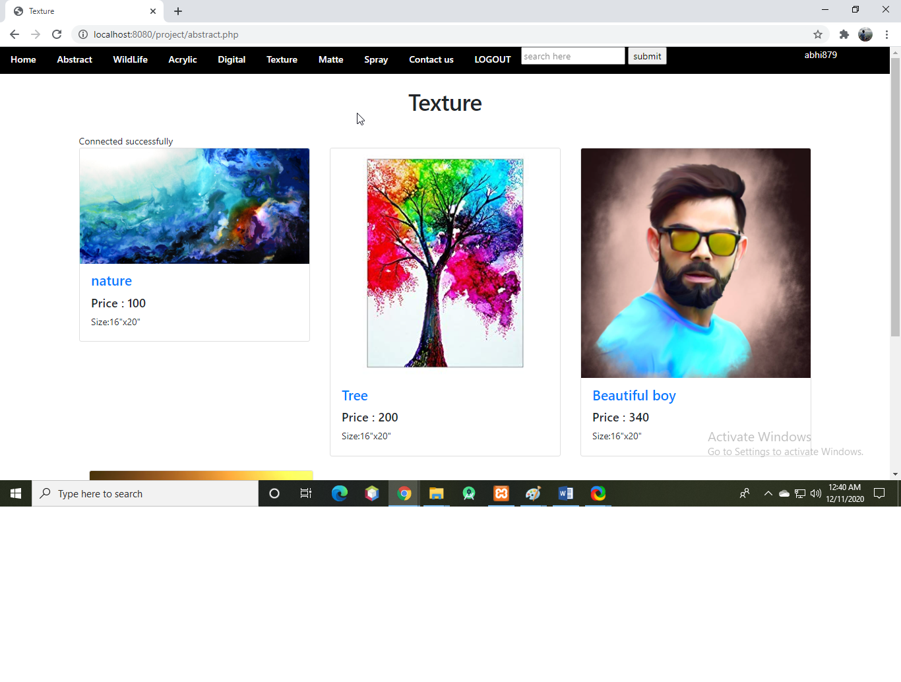

1. Wildlife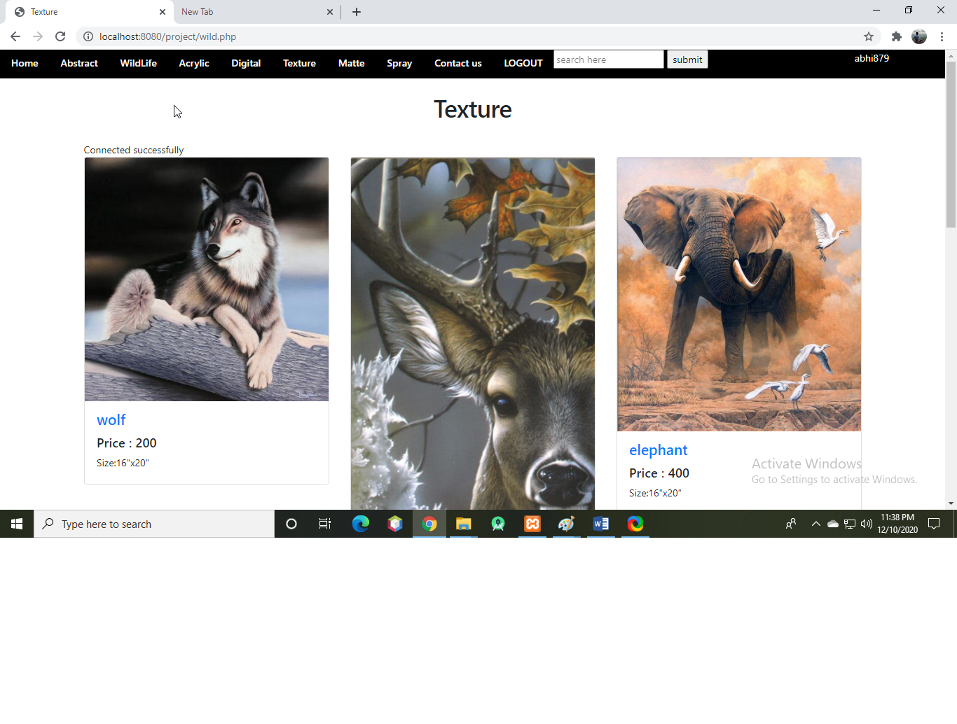
2. Acrylic

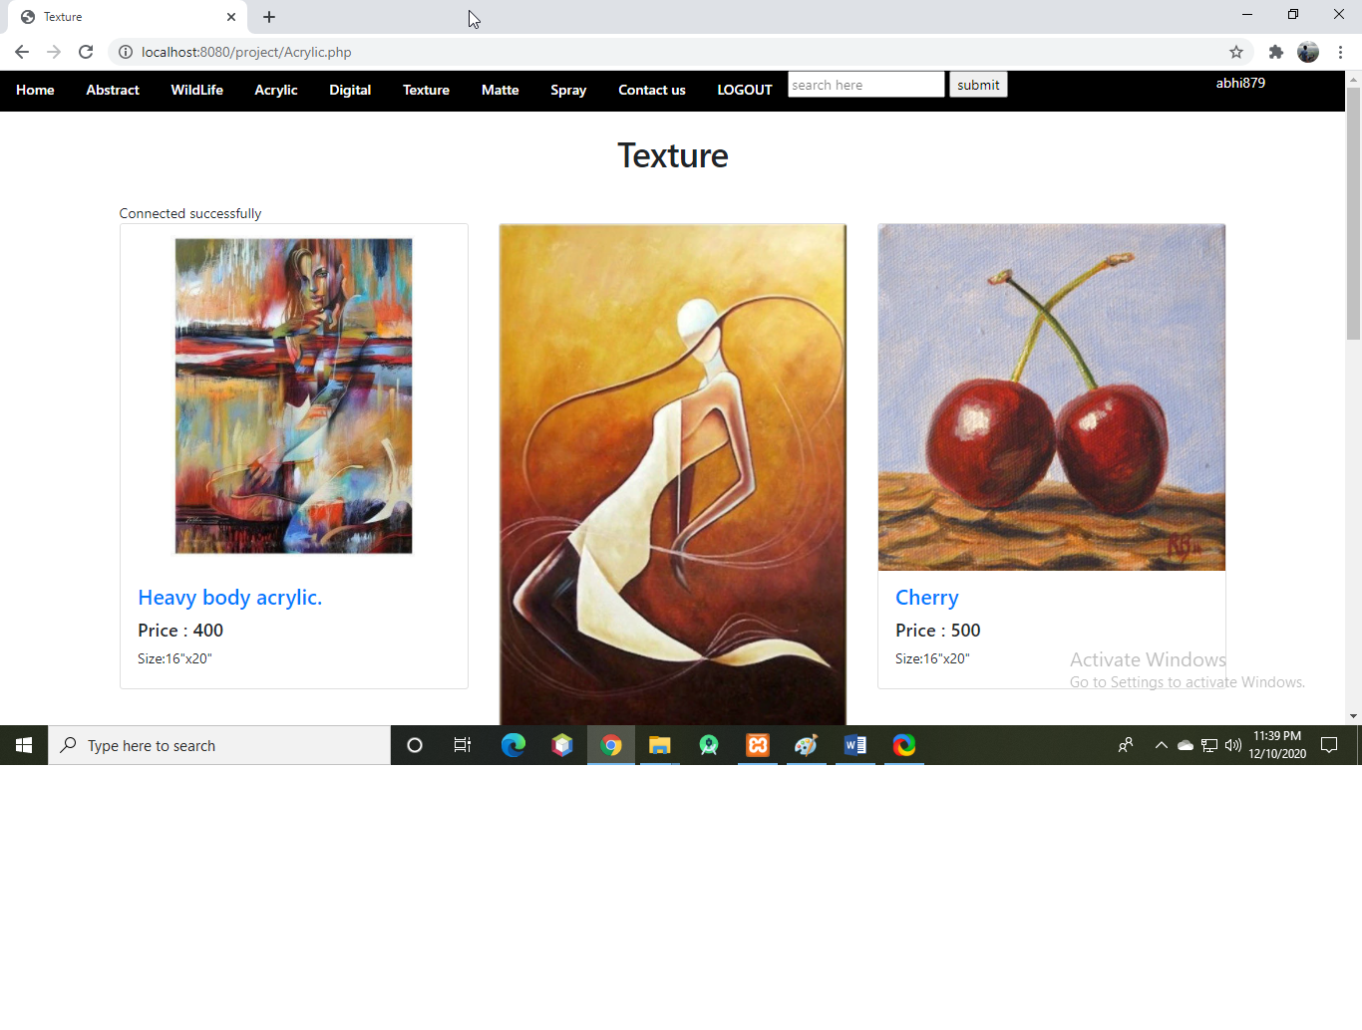

1. Digital

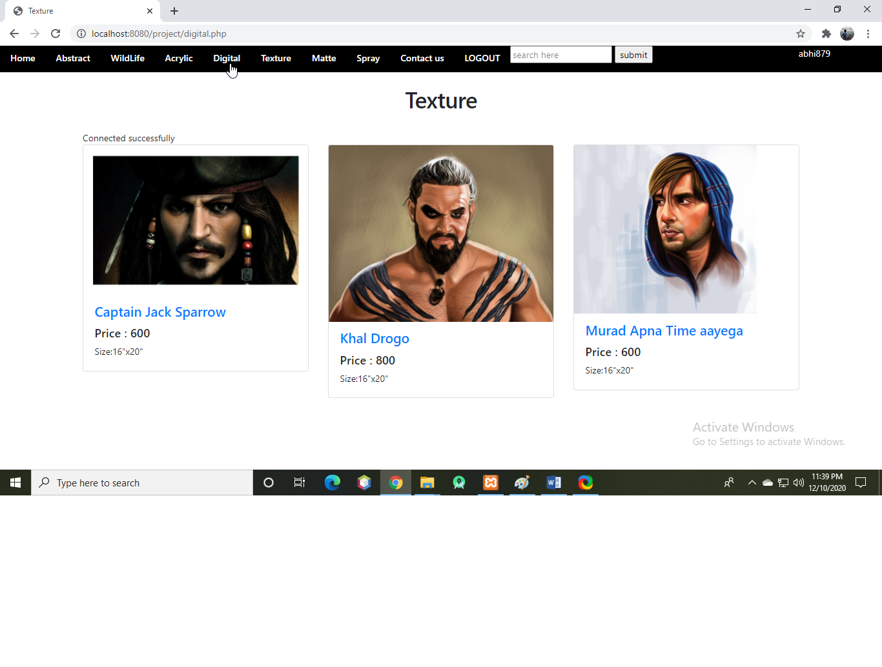

1. Texture

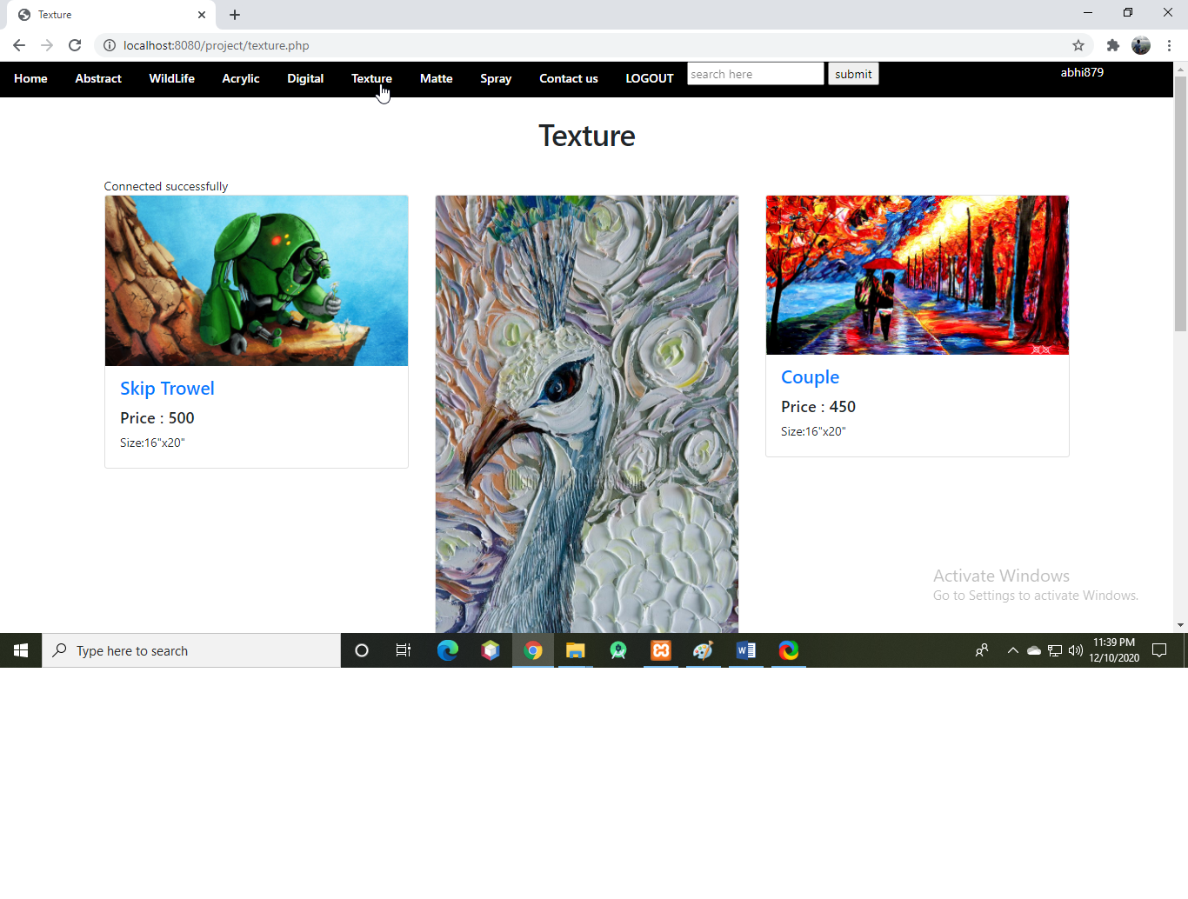

1. Matte

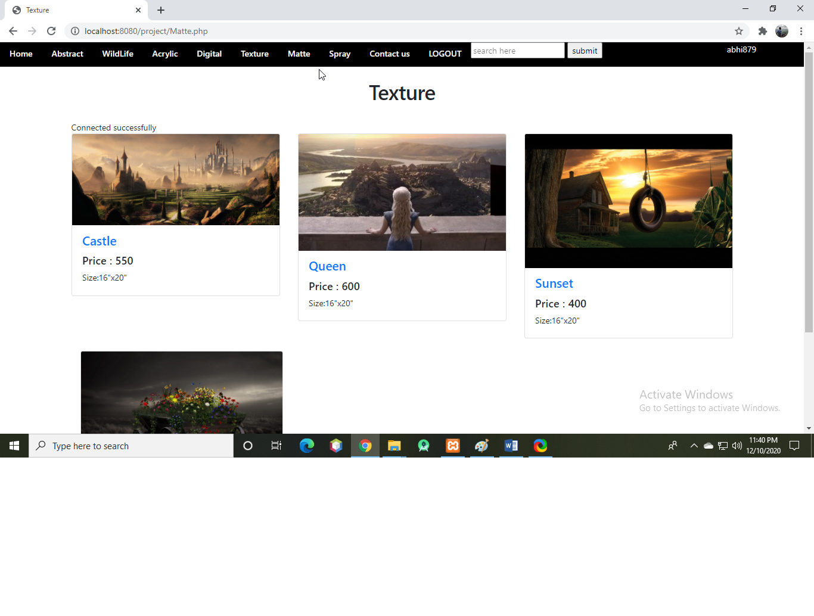

1. Spray

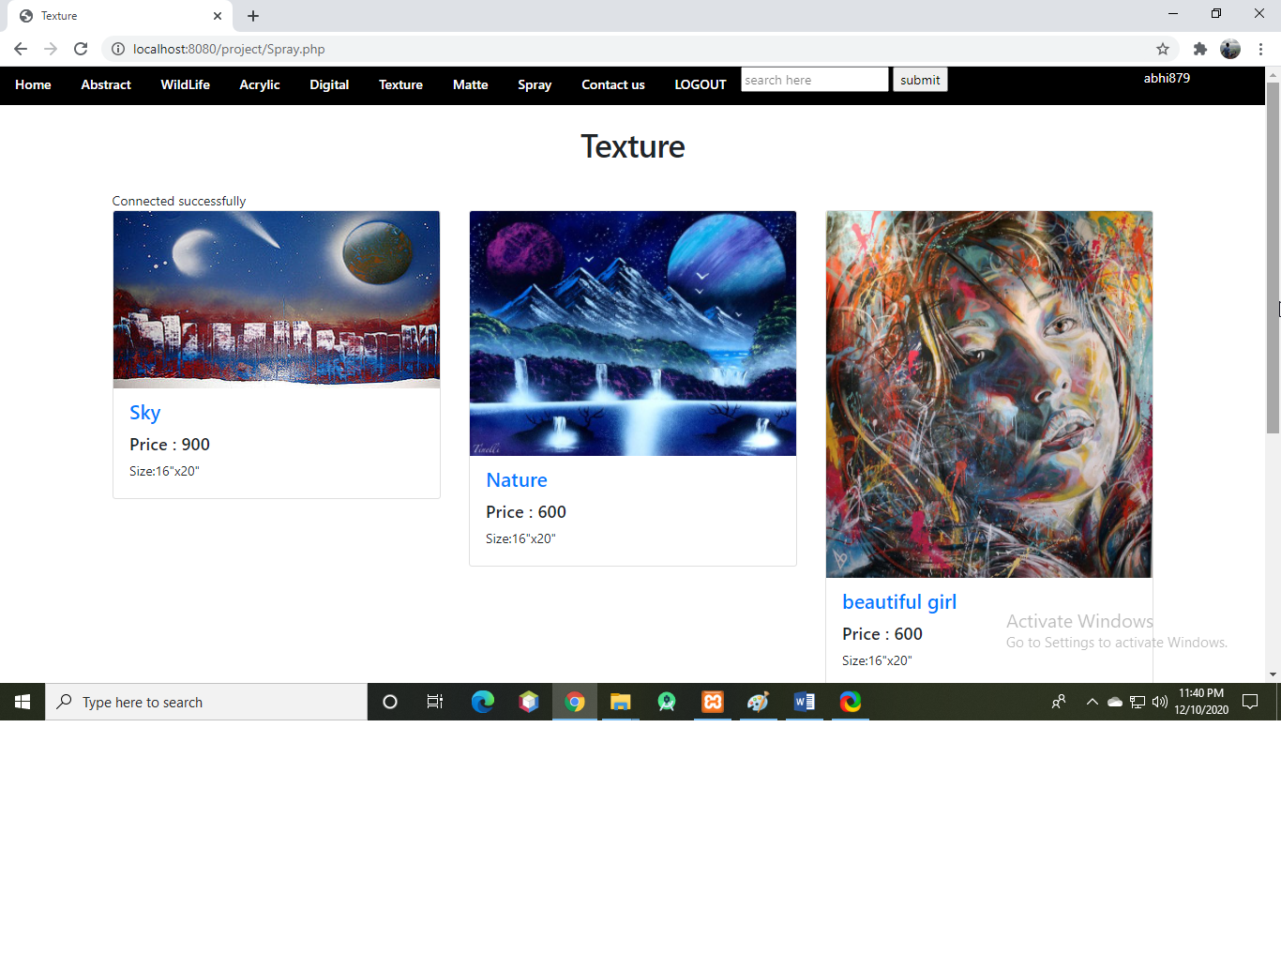

* Contact us:

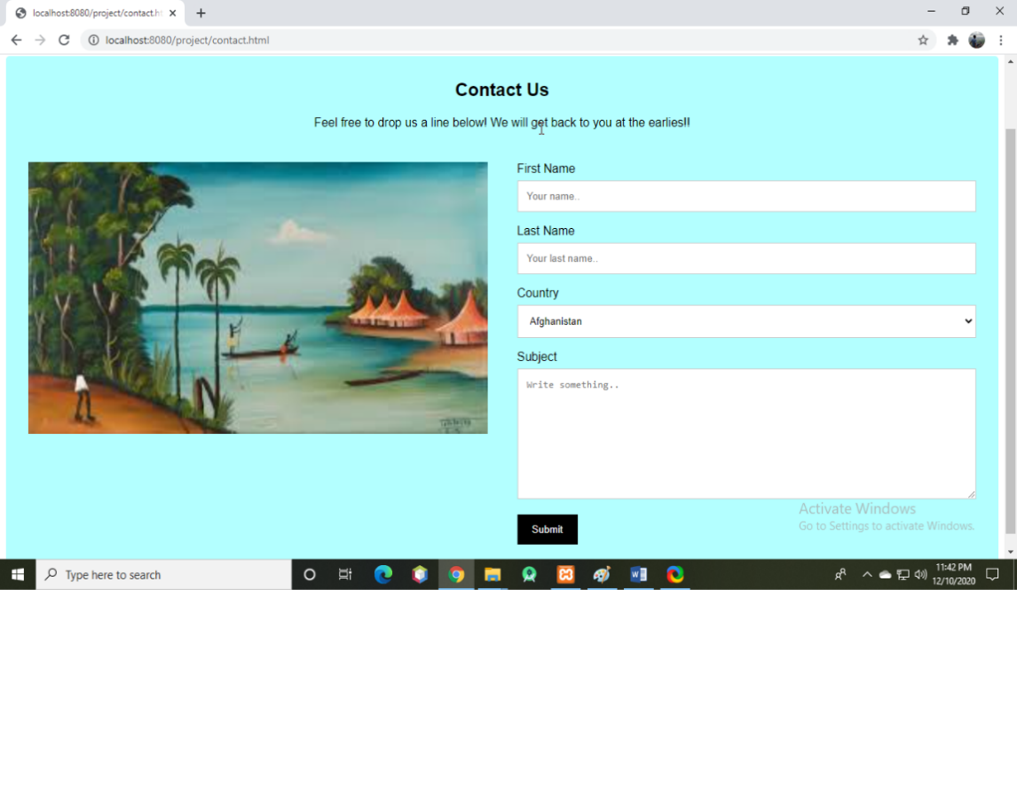

* Add to cart:

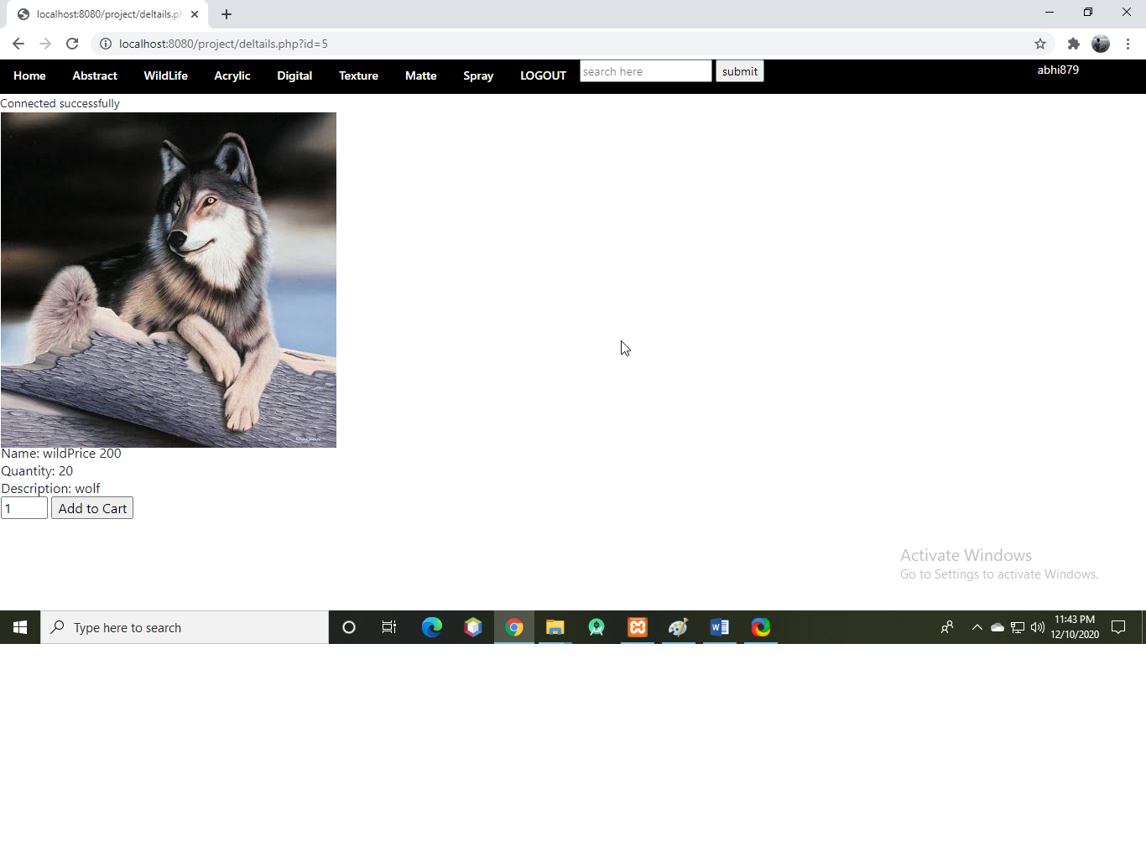

* Cart:

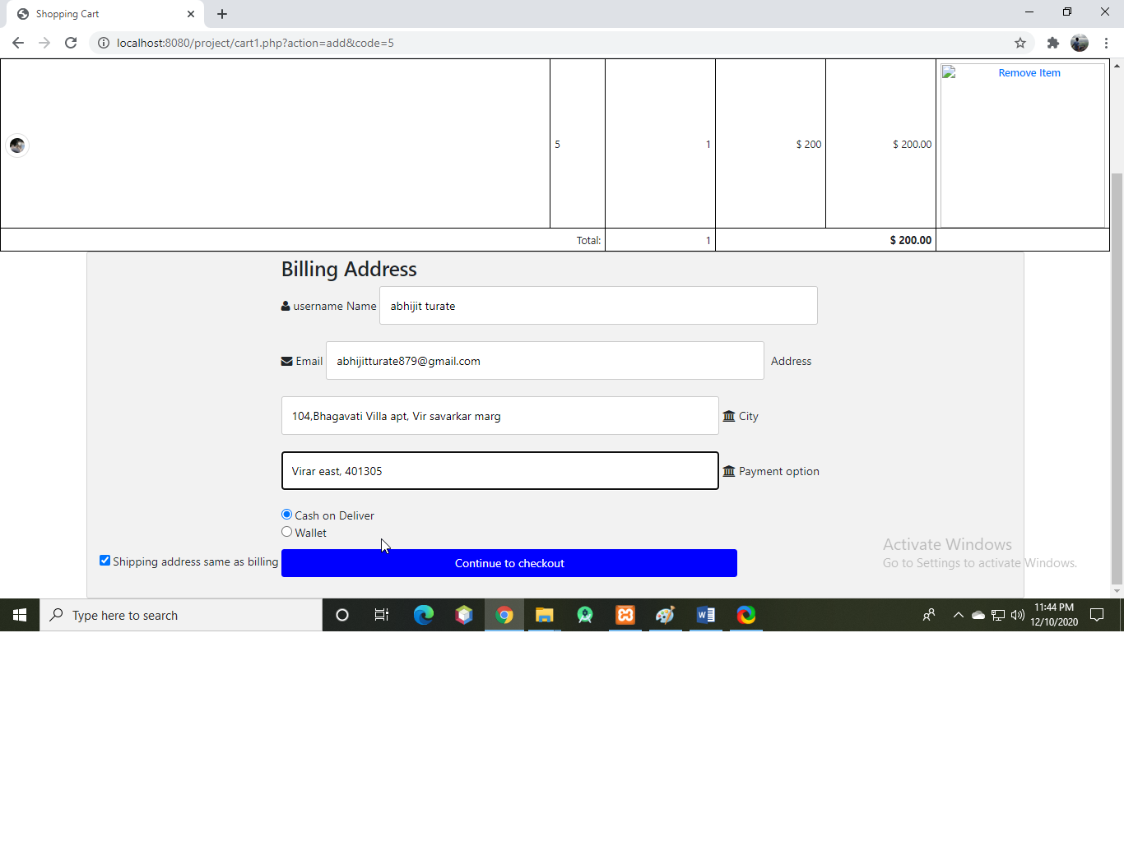

* Invoice:

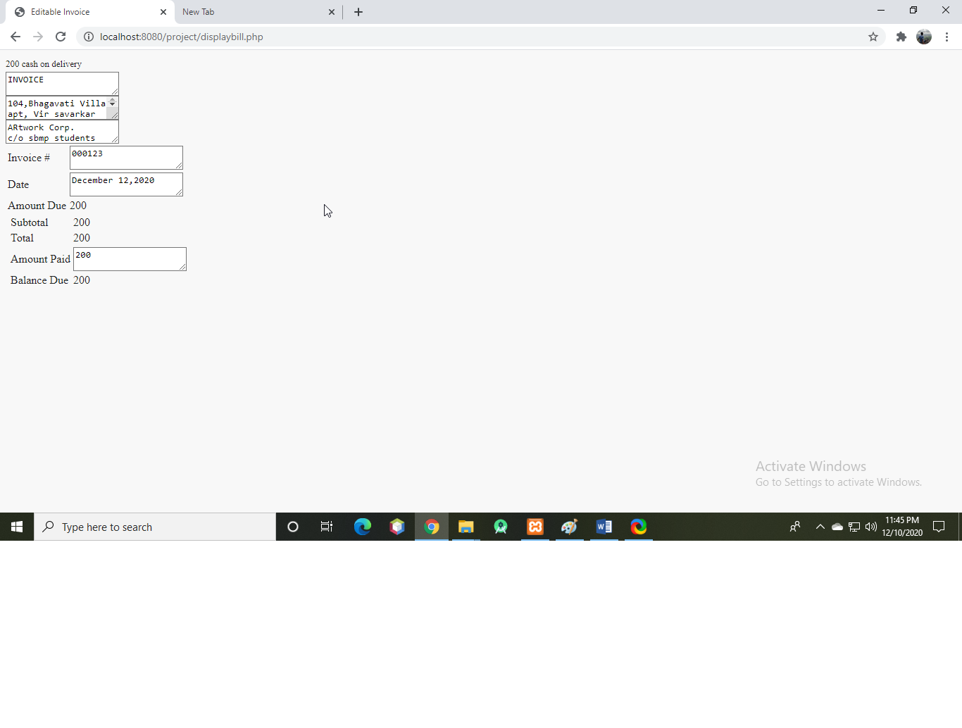

**CHAPTER 7**

**TESTING PROCEDURE**

**TESTING PROCEDURE**

**7.1 Testing**

Testing is the process of evaluating a system or its component(s) with the intent to find that whether it satisfies the specified requirements or not. Testing is executing a system in order to identify any gaps, errors or missing requirements in contrary to the actual desire or requirements.

A test case is a document, which has a set of test data, preconditions, expected results and postconditions, developed for a particular test scenario in order to verify compliance against a specific requirement.

Test Case acts as the starting point for the test execution, and after applying a set of input values, the application has a definitive outcome and leaves the system at some end point or also known as execution postcondition.

Test Case Parameters:

Test Case ID

Test Scenario

Test Case Description

Test Steps

Prerequisite

Test Data

Expected Result

Actual Result

Comments

The following are the test cases:

**Test Case Id:** 01

**Test Objective:** To test login and registration.

|  |  |  |  |  |
| --- | --- | --- | --- | --- |
| **Sr no.** | **Test cases** | **Expected result** | **Observed result** | **Status** |
| 1 | Click on “login“ button with member log in credentials | User profile will be opened | User profile is opened | PASS |
| 2 | Click on “signup” | User will be directed to sign up page | User is directed to sign up page | PASS |
| 3 | Click on “login” | User will be directed to sign in page | User is directed to sign in page | PASS |
| 4 | Click on “Register” with new user credentials | New user profile will be created | New user profile is created | PASS |
| 5 | Check clicking on “Register” button without selecting the checkbox of "I agree all statements in terms of services.” | Will not be able to click on “Register” button | Could not click on “Register” button | PASS |

**Table no. 7.1 Test Cases for login and registrations.**

**Test Case Id:** 02.

**Test Objective:** To test the cart module.

|  |  |  |  |  |
| --- | --- | --- | --- | --- |
| **Sr no** | **Test cases** | **Expected result** | **Observed result** | **Status** |
| 1 | Successfully adding items to cart | Items will be added to cart | Items added successfully in cart | **PASS** |
| 2 | Successfully deleting items to cart | Items will be deleted from cart | Items successfully deleted from cart | **PASS** |
| 3 | Adding multiple items of different types and verify | Multiple items will be added to the cart | Multiple items added to the cart successfully | **PASS** |
| 4 | Add the same item multiple times and verify | Item will be added to the cart | Item added to the cart successfully | **PASS** |

**Table no. 7.2 Test Cases for cart.**

**CHAPTER 8**

**GANTT CHART**

**Gantt chart**

A Gantt chart is a horizontal bar chart. Frequently used in project management, a Gantt chart provides a graphical illustration of a schedule that helps to plan, coordinate, and track specific tasks in a project. A Gantt chart is constructed with a horizontal axis representing the total time span of the project, broken down into increments (for example, days, weeks, or months) and a vertical axis representing the tasks that make up the project, for example, if the project is outfitting your computer with new software, the major tasks involved might be: conduct research, choose software, install software.

|  |  |  |
| --- | --- | --- |
|  |  |  |
|  |  | Table 8.1 Project Development Phases |
|  | **1** | **Analysis Phase** |
|  |  |  |
|  | 1.1 | Study of existing system |
|  |  |  |
|  | 1.2 | Study of discussion and research papers |
|  |  |  |
|  | 1.3.1 | Problem definition |
|  |  |  |
|  | 1.3.2 | Scope |
|  |  |  |
|  | 1.3.3 | Feasibility |
|  |  |  |
|  | 1.4 | Defining the problem |
|  |  |  |
|  | 1.5 | Fixing the scope of the project |
|  |  |  |
|  | 1.6 | Feasibility analysis |
|  |  |  |
|  | 1.7 | Requirement analysis |
|  |  |  |
|  | 1.8 | Project estimation |
|  |  |  |
|  | **2** | **Design Phase** |
|  |  |  |
|  | 2.1 | Designing Solar Tracking Module and Data Mining software |
|  |  |  |
|  | 2.2 | Developing the recommendation approaches and other algorithms required |
|  |  |  |
|  | 2.3 | Developing data flow diagrams of the system |
|  |  |  |
|  | **3** | **Assembling hardware and Coding** |
|  |  |  |
|  | 3.1 | Completing the Facial module and Coding algorithm |
|  |  |  |
|  | 3.2 | Coding module |
|  |  |  |
|  | **4** | **Testing** |
|  |  |  |
|  | 4.1 | Unit Testing |
|  |  |  |
|  | 4.2 | Integration Testing |
|  |  |  |
|  | 4.3 | System Testing |
|  |  |  |
|  | **5** | **Deployment** |
|  |  |  |
|  | **6** | **Documentation** |
|  |  |  |

8.1 Timeline Chart

Table 8.2 Work Task 1: Analysis Phase

|  |  |  |  |  |  |  |  |  |  |  |  |  |
| --- | --- | --- | --- | --- | --- | --- | --- | --- | --- | --- | --- | --- |
| Work | Wk | Wk | Wk | Wk | Wk | Wk | Wk | Wk | Wk | Wk | Wk | Wk |
| Task | 1 | 2 | 3 | 4 | 5 | 6 | 7 | 8 | 9 | 10 | 11 | 12 |
|  |
|  |  |  |  |  |  |  |  |  |  |  |  |  |
| 1.1 |  |  |  |  |  |  |  |  |  |  |  |  |
|  |  |  |  |  |  |  |  |  |  |  |  |  |
| 1.2 |  |  |  |  |  |  |  |  |  |  |  |  |
|  |  |  |  |  |  |  |  |  |  |  |  |  |
| 1.3.1 |  |  |  |  |  |  |  |  |  |  |  |  |
|  |  |  |  |  |  |  |  |  |  |  |  |  |
| 1.3.2 |  |  |  |  |  |  |  |  |  |  |  |  |
|  |  |  |  |  |  |  |  |  |  |  |  |  |
| 1.3.3 |  |  |  |  |  |  |  |  |  |  |  |  |
|  |  |  |  |  |  |  |  |  |  |  |  |  |
| 1.4 |  |  |  |  |  |  |  |  |  |  |  |  |
|  |  |  |  |  |  |  |  |  |  |  |  |  |
| 1.5 |  |  |  |  |  |  |  |  |  |  |  |  |
|  |  |  |  |  |  |  |  |  |  |  |  |  |
| 1.6 |  |  |  |  |  |  |  |  |  |  |  |  |
|  |  |  |  |  |  |  |  |  |  |  |  |  |
| 1.7 |  |  |  |  |  |  |  |  |  |  |  |  |
|  |  |  |  |  |  |  |  |  |  |  |  |  |
| 1.8 |  |  |  |  |  |  |  |  |  |  |  |  |
|  |  |  |  |  |  |  |  |  |  |  |  |  |



Table 8.3 Work Task 2: Design Phase

|  |  |  |  |  |  |  |  |  |  |  |  |  |
| --- | --- | --- | --- | --- | --- | --- | --- | --- | --- | --- | --- | --- |
| Work | Wk | Wk | Wk | Wk | Wk | Wk | Wk | Wk | Wk | Wk | Wk | Wk |
| Task | 13 | 14 | 15 | 16 | 17 | 18 | 19 | 20 | 21 | 22 | 23 | 24 |
|  |  |  |  |  |  |  |  |  |  |  |  |  |
| 2.1 |  |  |  |  |  |  |  |  |  |  |  |  |
|  |  |  |  |  |  |  |  |  |  |  |  |  |
| 2.2 |  |  |  |  |  |  |  |  |  |  |  |  |
|  |  |  |  |  |  |  |  |  |  |  |  |  |
| 2.3 |  |  |  |  |  |  |  |  |  |  |  |  |
|  |  |  |  |  |  |  |  |  |  |  |  |  |



Table 8.4 Work Task 3: Coding, Deployment and Documentation Phase

|  |  |  |  |  |  |  |  |  |  |  |  |  |
| --- | --- | --- | --- | --- | --- | --- | --- | --- | --- | --- | --- | --- |
| Work | Wk | Wk | Wk | Wk | Wk | Wk | Wk | Wk | Wk | Wk | Wk | Wk |
| Task | 25 | 26 | 27 | 28 | 29 | 30 | 31 | 32 | 33 | 34 | 35 | 36 |
|  |  |  |  |  |  |  |  |  |  |  |  |  |
| 3.1 |  |  |  |  |  |  |  |  |  |  |  |  |
|  |  |  |  |  |  |  |  |  |  |  |  |  |
| 3.2 |  |  |  |  |  |  |  |  |  |  |  |  |
|  |  |  |  |  |  |  |  |  |  |  |  |  |
| 4.1 |  |  |  |  |  |  |  |  |  |  |  |  |
|  |  |  |  |  |  |  |  |  |  |  |  |  |
| 4.2 |  |  |  |  |  |  |  |  |  |  |  |  |
|  |  |  |  |  |  |  |  |  |  |  |  |  |
| 4.3 |  |  |  |  |  |  |  |  |  |  |  |  |
|  |  |  |  |  |  |  |  |  |  |  |  |  |
| 5 |  |  |  |  |  |  |  |  |  |  |  |  |
|  |  |  |  |  |  |  |  |  |  |  |  |  |
| 6 |  |  |  |  |  |  |  |  |  |  |  |  |
|  |  |  |  |  |  |  |  |  |  |  |  |  |



**CHAPTER 9**

**CONCLUSION**

**CONCLUSION**

The site was created keeping in mind the simplicity of use by the users and to enable the artists to grow their reach to people hustle free. This site reduces the manual work for artists. This site was created in such a way to make all types of paintings available on one site. This site will encourage the artists and will help people of our country to get to know more about art. Beginners and local artists will get a ready platform to showcase their talent and earn from it.

**CHAPTER 10**

**FUTURE SCOPE**

**FUTURE SCOPE**

Following can be the future scope for the proposed system:

The future scope in the site would be to design a forum in which people could ask questions and communicate easily with the artists. This will help people to know more about art and will be able to communicate with artists directly. Another future scope can be to add a section where people can get their paintings customized by their desired artists.

**REFERENCES**

* <https://www.artzolo.com/>
* <https://ignouprojectguru.com/synopsis-on-art-of-the-artists/>
* <https://artsartistsartwork.com/>
* <https://www.marketresearch.com/IBISWorld-v2487/Online-Paint-Sales-Research-12575712/>